**HOENN SAFARI ZONE RESEARCH**

Analysis by [Professor Rex](https://www.youtube.com/channel/UCqsQ925jAVYz-asz--B5Nfw)/[Rex_PHD](https://www.instagram.com/rex_phd/)

Forward:

When looking through the Bulbapedia page for the Hoenn Safari Zone something jumped out at me… the guide didn’t take into account the 15% chance of a Pokémon fleeing on the first turn. Something that can happen regardless of how skilled you are at throwing Pokéblocks. To rectify this, I took a dive into the source code of Pokémon Ruby & Sapphire. Read through for a full understanding of the Hoenn Safari Zone & learn how to guarantee a successful catch rate of at least 70% in any encounter!  
TO SKIP TO THE CATCH GUIDE: CLICK HERE

The Catch Factor

The Hoenn Safari Zone calculates Catch Factors in the same way that Pokémon Firered and Leafgreen do in their Safari Zones. [For more information see my Kanto Safari Zone Research.](https://docdro.id/Tx5NbeU)  
The main thing to take away is that catch rates in the Safari zone always end up being less than or equal to their usual catch rates.  
  
The Flee Factor

Snippet of code for getting catch and flee factors

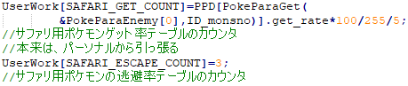

The Hoenn Flee factors are quite a bit different than the Flee Factors in Kanto though with all Pokémon encounters starting with a base flee factor of 3, which is equal to 15% per turn.  
This flee factor can be modified by going near, or throwing Pokéblocks.  
The flee factor cannot be reduced below 0, or increased above 20.  
It should be noted that modifications to the Flee Factor do not affect the flee check of the current turn. Flee Factor changes do not take effect until the following turn’s flee check.  
A flee check is preformed at the start of each turn by multiplying the current flee factor by 5 and comparing it to a random number between 0-99 (inclusive). If the random number is less, the Pokémon will flee at the end of the turn unless it is caught first.

Snippet of code for preforming flee checks

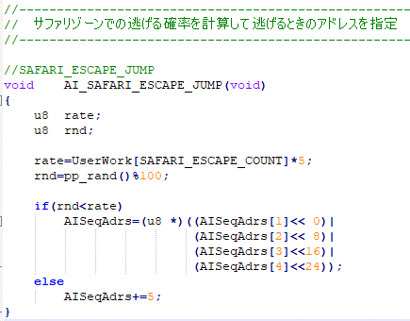

VER 2.0a (2024-06-17)

Go Near

Snippet of code that demonstrates how going near works

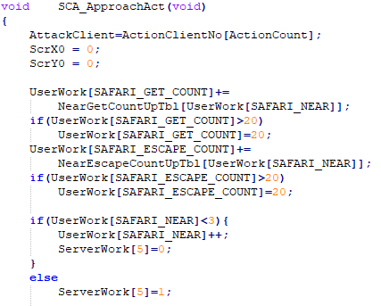

Going near a Pokémon is entirely useless, upon first going near a Pokémon the catch factor and the flee factor will both increase by 4. The second and third attempts to go near will increase the catch factor by 3 & 2 respectively while still increasing the flee factor by 4 each time. Any attempts to go near past the third will display the message “*PLAYER* can’t get any closer!”; despite this the Flee Factor will still increase by 4 and the catch factor by 1. For a Pokémon such as Heracross this brings it’s Catch Factor to 7 which is about 19.75% per ball; up from 8.09%. However, it’s flee rate also increases by 20%, up to 35% per turn. This risk will never even out and you are better off chucking balls than attempting to get closer to the Pokémon.

Snippet of code that shows how the effects of going near change the more you do it

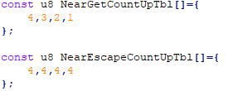

Pokéblocks

|  |  |  |  |  |
| --- | --- | --- | --- | --- |
| Pokéblock # -> | First | Second | Third | Fourth+ |
| Neutral Pokéblock | -3 | -2 | -1 | -1 |
| Liked Pokéblock | -5 | -3 | -2 | -1 |
| Disliked Pokéblock | ±0 | ±0 | ±0 | ±0 |

It is well known that throwing Pokéblocks in the Hoenn Safari Zone can bring a Pokémon’s flee factor down to 0. Doing so is quite easy yet slightly counter-intuitive. When you first encounter a Pokémon, the base flee factor is always 3. Our goal is to reduce this down as low as possible. One might assume that throwing a Pokéblock that the wild Pokémon likes would be the right move. However, this isn’t the case. We actually want to throw a neutral Pokéblock to reduce the flee factor to 0. The reason for this is that on the first thrown Pokéblock will drop flee rate by 3 if it is neutral, 5 if they like it, or 0 if they don't like it. A reduction by 5 sounds like it should do the trick right? Unfortunately, not. If a Pokémon’s flee rate is greater than 1, attempting to reduce the flee rate below 0 will instead change the flee rate to 1. Reducing it to exactly 0 will work. On the first turn our goal is actually to throw a neural Pokéblock. This will bring the Flee Rate down to exactly 0**.** If a Pokémon’s flee factor is 1, it cannot be reduced further with Pokéblocks.

Table that stores how Pokéblocks effectiveness change as more are thrown

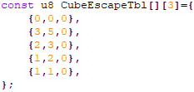

Snippet of code that demonstrates how Pokéblocks affect Flee Rates

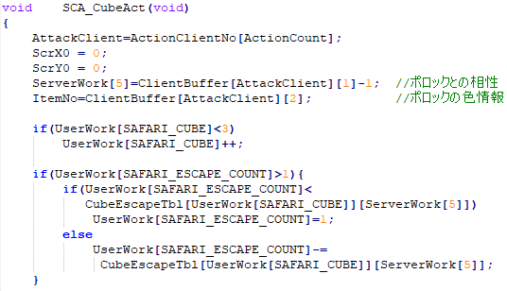

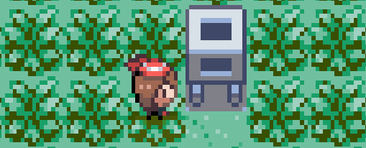Pokéblock Feeder

Original code for getting a random nature that matches flavor

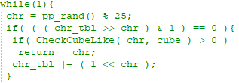

The Pokéblock feeder in the Hoenn Safari Zone allows players to manipulate the natures of the Pokémon that are encountered. Once a Pokéblock is inserted into the feeder each encountered Pokémon has an 80% chance to be forced to have a nature which enjoys the same flavor as the Pokéblock that has been put into the feeder. When the Safari zone was first being designed this was planned to be done through a repeating random call that would run until such a nature was found. However, at some point in development this was changed to be done by “randomizing” the nature table and then using the first matching nature found after this randomization. Interestingly the randomization algorithm they used to make this randomized list of natures doesn’t actually do a great job of randomizing the natures. Below are 5 lists of natures that have been created using this nature randomizer. You will notice that for something that should be random they all look eerily similar.

Production code for getting a random nature that matches flavor [Version with comments](https://i.imgur.com/wv1vS9b.png)

[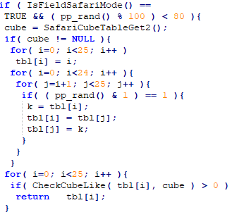](https://i.imgur.com/wv1vS9b.png)

(Each number corresponds to a Nature ID as listed in the chart to the right)

| **#** | **Nature** | **Favorite flavor** | **Disliked flavor** |
| --- | --- | --- | --- |
| 0 | **Hardy** | — | — |
| 1 | **Lonely** | Spicy | Sour |
| 2 | **Brave** | Spicy | Sweet |
| 3 | **Adamant** | Spicy | Dry |
| 4 | **Naughty** | Spicy | Bitter |
| 5 | **Bold** | Sour | Spicy |
| 6 | **Docile** | — | — |
| 7 | **Relaxed** | Sour | Sweet |
| 8 | **Impish** | Sour | Dry |
| 9 | **Lax** | Sour | Bitter |
| 10 | **Timid** | Sweet | Spicy |
| 11 | **Hasty** | Sweet | Sour |
| 12 | **Serious** | — | — |
| 13 | **Jolly** | Sweet | Dry |
| 14 | **Naive** | Sweet | Bitter |
| 15 | **Modest** | Dry | Spicy |
| 16 | **Mild** | Dry | Sour |
| 17 | **Quiet** | Dry | Sweet |
| 18 | **Bashful** | — | — |
| 19 | **Rash** | Dry | Bitter |
| 20 | **Calm** | Bitter | Spicy |
| 21 | **Gentle** | Bitter | Sour |
| 22 | **Sassy** | Bitter | Sweet |
| 23 | **Careful** | Bitter | Dry |
| 24 | **Quirky** | — | — |

[19, 24, 23, 22, 15, 21, 16, 17, 20, 11, 18, 7, 10, 12, 6, 14, 13, 4, 5, 3, 9, 1, 0, 2, 8]

[22, 23, 24, 12, 21, 15, 20, 18, 3, 19, 13, 16, 17, 14, 9, 11, 5, 6, 2, 10, 1, 0, 7, 8, 4]

[24, 22, 19, 23, 10, 18, 20, 21, 14, 12, 17, 15, 13, 1, 5, 16, 11, 9, 7, 2, 6, 0, 4, 8, 3]

[23, 22, 16, 24, 21, 17, 18, 12, 8, 5, 10, 19, 15, 14, 20, 0, 4, 11, 9, 1, 7, 13, 2, 3, 6]

[23, 13, 22, 24, 21, 20, 15, 18, 12, 11, 3, 19, 17, 10, 14, 9, 5, 8, 7, 16, 6, 4, 2, 1, 0]

The lists all follow a pattern that looks to have the high numbers frequently in early positions and lower numbers in later positions. As suspected, this creates an uneven distribution of what natures are selected when a Pokéblock has been put into the feeder. This can be a huge help when making decisions on which neutral Pokéblocks to throw.  
The following odds were derived from 10,000,000 trials and are the odds of getting a specific nature if the 80% forced nature check passes.

Nature table from [Bulbapedia](https://bulbapedia.bulbagarden.net/wiki/Nature)

**Bitter Pokéblock in feeder:**

Calm has an 8.71% chance

Gentle has a 15.61% chance

Sassy has a 27.66% chance

Careful has a 48.02% chance

**Dry Pokéblock in feeder:**

Modest has a 11.66% chance

Mild has a 16.95% chance

Quiet has a 24.16% chance

Rash has a 47.23% chance

**Spicy Pokéblock in feeder:**

Lonely has a 22.00% chance

Brave has a 23.17% chance

Adamant has a 25.57% chance

Naughty has a 29.25% chance

**Sour Pokéblock in feeder:**

Bold has a 14.01% chance

Relaxed has a 22.47% chance

Impish has a 28.28% chance

Lax has a 35.24% chance

**Sweet Pokéblock in feeder:**

Timid has a 12.93% chance

Hasty has a 17.36% chance

Jolly has a 30.37% chance

Naive has a 39.34% chance

Optimizing Pokéblocks (The Simple Way)

Knowing that some natures are more likely than others allows us to optimize our choice of Pokéblock for our first throw. In all cases the best option is to throw a Pokéblock that is disliked by the nature with the lowest chance to occur. For example, when a Bitter Pokéblock is in the feeder there is only an 8.71% chance that a forced roll will result in a Calm nature. Looking at the nature table we can see that in this case our best bet is to throw a Spicy Pokéblock. Overall, this would give us an 86.6% chance of our first Pokéblock being a neutral one and dropping the flee rate to 0. For reference the odds of getting a neutral Pokéblock when throwing a random flavor at a random nature is 68% (17/25).

Best-Case Scenario:  
**Spicy Pokéblock in feeder:** throw a *sour* Pokéblock, 76.00% chance for neutral Pokéblock  
**Sour Pokéblock in feeder:** throw a *spicy* Pokéblock, 82.39% chance for neutral Pokéblock  
**Sweet Pokéblock in feeder:** throw a *spicy* Pokéblock, 83.25% chance for neutral Pokéblock  
**Dry Pokéblock in feeder:** throw a *spicy* Pokéblock, 84.28% chance for neutral Pokéblock  
**Bitter Pokéblock in feeder:** throw a *spicy* Pokéblock, 86.63% chance for neutral Pokéblock

Optimizing Pokéblocks (The Complex Way)

When looking into optimizing Pokéblocks for the Pokéblock feeder the first time around, I only ever considered the single-flavour Pokéblocks. This leaves a massive entry-point for natures that will dislike your thrown Pokéblock to slip through. With a BitterPokéblockin the feeder, there is still an 8.69% chance that when the feeder triggers a Calm natured Pokémon will slip through. When the feeder triggers there is only a 91.3% chance that our Spicy Pokéblock will be neutral. We started thinking if that was really the best there was. To figure out the answer, we have to understand a little bit more about how Pokéblocks are determined to be liked, disliked, or neutral.  
  
How Pokéblocks are Eaten:

Each berry has a certain strength for each of the 5 flavours.  
For Example, the Chesto Berry has Dry flavour strength of 10 and 0 strength in the other four flavours.  
The Oran Berry is a neutral berry of sorts as it has a strength of 10 in all four flavours.  
When berries are mixed together their strengths are combined and then the flavours battle it out.  
**Spicy** is reduced by the total **Dry** strength, **Dry** by **Sweet**, **Sweet** by **Bitter**, **Bitter** by **Sour**, and **Sour** by **Spicy**. In the example of the Chesto and the Oran berry, all of the Oran Berry’s flavours just cancel each-other out and the Chesto Berry’s Dry strength leaves Spicy at negative 10 while Dry remains at 10.

After all the mixing is done the negative flavours are reset to zero, positive strengths are reduced by the total number of negative flavours, and we can look at what flavours remain. The remaining flavours are used to determine how a Pokémon will react to the Pokéblock.

To do this, each flavor is compared to the like/dislike table for the Pokémon’s nature. The likeability of a Pokéblock starts at 9. If the flavour is liked, that flavour’s strength is added to the likeability, if the flavour is disliked it is subtracted. If the total likability is positive, then a Pokémon of that nature would like that Pokéblock, if the likability is 0 then that nature would treat that Pokéblock neutrally, and if the likability is negative, the Pokéblock would be disliked by that nature.  
  
EXAMPLE MIX:  
LUM BERRY: **10 Spicy**, **10 Dry**, **10 Sweet**, **10 Bitter**, **10 Sour**  
RAWST BERRY: **0 Spicy**, **0 Dry**, **0 Sweet**, **10 Bitter**, **0 Sour**  
CHERI BERRY: **10 Spicy**, **0 Dry**, **0 Sweet**, **0 Bitter**, **0 Sour**TOTAL MIX: **20 Spicy**, **10 Dry**, **10 Sweet**, **20 Bitter**, **10 Sour**  
**Spicy** = **20 Spicy - 10 Dry = 10  
Dry** = **10 Dry - 10 Sweet** = **0  
Sweet** = **10 Sweet - 20 Bitter** = **(10)  
Bitter** = **20 Bitter - 10 Sour = 10  
Sour** = **10 Sour** - **20 Spicy = (10)**Since there are 2 negative flavours, they get reset to 0, and the positive flavours are reduced by 2.  
FINAL MIX: **8 Spicy**, **0 Dry**, **0 Sweet**, **8 Bitter**, **0 Sour**

EXAMPLE NATURE CALCULATIONS:  
CALM – Favourite Flavour: **Bitter**, Disliked Flavour: **Spicy**Likability = **Bitter - Spicy** = **8 - 8** = **0**Since the likability is zero, this Pokéblock would be treated neutrally by Calm Pokémon

CAREFUL – Favourite Flavour: **Bitter**, Disliked Flavour: **Dry**Likability = **Bitter - Dry** = **8 - 0** = **8**Since the likability is positive, this Pokéblock would be LIKED by Careful Pokémon

This Purple Pokéblock is actually extremely powerful. By adding in that little bit of spice, we are able to make a Pokéblock that acts very similar to the **Bitter** Pokéblock in the feeder, but won’t attract Calm Pokémon. The above Pokéblock can be made in single player by using a Lum berry with two NPCs. It is only liked by Lonely, Brave, Adamant, Gentle, Sassy, and Careful Pokémon. Since Lonely, Brave, and Adamant have such low ID numbers there is less than a 0.0012% chance to generate any of them when the Pokéblock feeder has this Pokéblock in it and triggers. That means there is over a 99.998% chance to force a Gentle, Sassy, or Careful Nature. All of these are neutral if a **Spicy** Pokéblock is thrown.

How did we find this Pokéblock though? Well, I actually generated every possible Pokéblock, checked the natures that would like them and ranked every block. The above block is rank #8 out of the 294 possible flavour ratios. For comparison’s sake, bitter is rank 221/294.  
The Pokéblock Ranks can be found on this spreadsheet: [RANKING SHEET](https://docs.google.com/spreadsheets/d/14vZBAE3C9Xgr_Ai282rkHR69HM3AdqzIj3LlrMdppLY/edit?gid=0#gid=0)  
All Recipes for each rank can be found here: [POKEBLOCK SITE](https://professorrex.github.io/pokeblocks/)   
All Possible Pokéblocks for single-player can be found here with their Rank: [SINGLE PLAYER SHEET](https://docs.google.com/spreadsheets/d/1jH2xx0ueqqNGvI40uWHHKkWOvlloUoRt0r_Xeiff7H0/edit?usp=sharing)

For curiosity’s sake, the best possible Pokéblock for the feeder has a flavour ratio of:  
**38 Spicy** : **8 Dry** : **0 Sweet** : **38 Bitter** : **0 Sour**This will only attract Careful, Sassy, Gentle, Mild, Quiet, Lonely, Brave, and Adamant natures.  
By adding in Quiet and Mild, we further minimize the odds of generating one of the Spicy lovers.  
All Recipes for the ULTIMATE feeder Pokéblock can be found here: [#1 BLOCK](https://professorrex.github.io/pokeblocks/WEBPAGES/BLOCKS/1_2_3_16_17_21_22_23.html)

Best Single-Player Complex Pokéblocks for the Feeder

These optimized Pokéblocks open up more variety for usable berries while also giving more freedom on the thrown Pokéblock without giving up much in the way of success rate

**Rank 8** Purple Pokéblock, 99.99+% Neutral when **Spicy** Pokéblock is thrown –   
2 NPC: Lum Berry, Wepear Berry, or Petaya Berry  
3 NPC: Lansat Berry, Pomeg Berry, or Razz Berry

**Rank 15** Purple Pokéblock, 99.99+% Neutral when **Spicy** Pokéblock is thrown –  
1 NPC: Pomeg Berry  
3 NPC: Leppa Berry, Figy Berry, or Spelon Berry

**Rank 40** Light Blue Pokéblock, 99.97+% Neutral when **Sour** Pokéblock is thrown –  
1 NPC: Wepear Berry

**Rank 84** Purple Pokéblock, 99.67% Neutral when **Spicy** Pokéblock is thrown –  
1 NPC: Razz Berry

**Rank 95** Purple Pokéblock, 99.55% Neutral when **Spicy** Pokéblock is thrown –  
1 NPC: Tamato Berry

**Rank 112** Brown Pokéblock, 99.43% Neutral when **Sweet** Pokéblock is thrown –  
1 NPC: Nanab Berry

**Rank 132** Brown Pokéblock, 98.84% Neutral when **Sweet** Pokéblock is thrown –  
1 NPC: Magost Berry, or Watmel Berry

**Rank 150** Indigo Pokéblock, 97.48% Neutral when **Sour** Pokéblock is thrown –  
2 NPC: Sitrus Berry, Pinap Berry, or Apicot Berry  
3 NPC: Starf Berry, Kelpsy Berry, Bluk Berry, or Oran Berry

**Rank 205** Indigo Pokéblock, 92.44% Neutral when **Dry** Pokéblock is thrown –  
2 NPC: Oran Berry, Bluk Berry, or Starf Berry  
3 NPC: Lum Berry, Wepear Berry, or Hondew Berry

Pokéblock Recipes for Throwing

**Spicy Red** Pokéblock – [ALL RECEPIES](https://professorrex.github.io/pokeblocks/WEBPAGES/BLOCKS/1_2_3_4.html)  
1 NPC: Cheri Berry, Leppa Berry, Figy Berry

**Dry Blue** Pokéblock – [ALL RECEPIES](https://professorrex.github.io/pokeblocks/WEBPAGES/BLOCKS/15_16_17_19.html)  
1 NPC: Chesto Berry, Oran Berry, Wiki Berry

**Sweet Pink** Pokéblock – [ALL RECEPIES](https://professorrex.github.io/pokeblocks/WEBPAGES/BLOCKS/10_11_13_14.html)  
1 NPC: Pecha Berry, Persim Berry, Mago Berry

**Bitter Green** Pokéblock – [ALL RECEPIES](https://professorrex.github.io/pokeblocks/WEBPAGES/BLOCKS/20_21_22_23.html)  
1 NPC: Rawst Berry, Lum Berry, Aguav Berry

**Sour Yellow** Pokéblock – [ALL RECEPIES](https://professorrex.github.io/pokeblocks/WEBPAGES/BLOCKS/5_7_8_9.html)  
1 NPC: Aspear Berry, Sitrus Berry, Iapapa Berry

Optimizing Patterns (with Pokéblock Feeder)

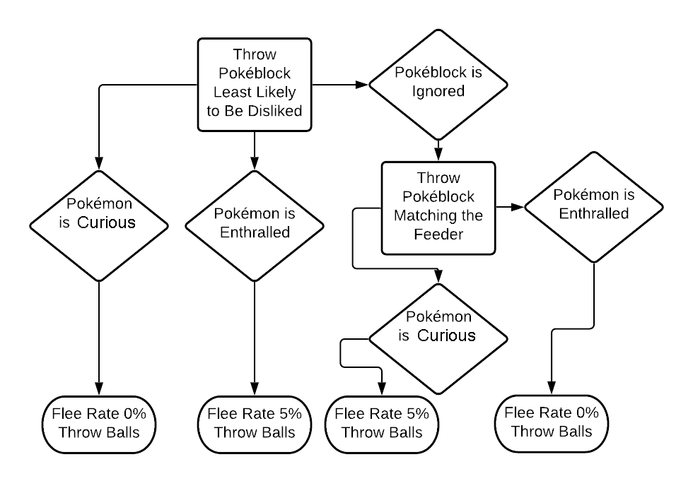Below is the best pattern to use in the Safari Zone while a Pokéblock feeder is in effect. Different Species of Pokémon do best with different patterns. Refer to the charts below to determine which pattern works best for the Pokémon you are attempting to catch.

**Optimal Pattern:** *throwing a second Pokéblock sometimes*  
On the first turn our goal is to throw a neural Pokéblock. This will bring the Flee Rate down to exactly 0. For the best chance to do this we want to throw a Pokéblock with a single flavour. If your first Pokéblock  **makes the wild Pokémon curious:** the flee rate is now 0%. Throw balls.

If your first Pokéblock is **ignored:** the second one you throw should attempt to be one the Pokémon likes. For the best chance to do this throw a Pokéblock that matches the flavor of the Pokéblock in the Pokéblock feeder. If the second Pokéblock enthralls the Pokémon the flee rate is now 0%. If the second Pokéblock does not enthrall the wild Pokémon, the flee rate is now 5%. In either case: throw balls.

If your first Pokéblock **enthralls the Pokémon:** the flee rate is now 5% per turn. Throw balls.

Optimizing Patterns (with Random Natures)

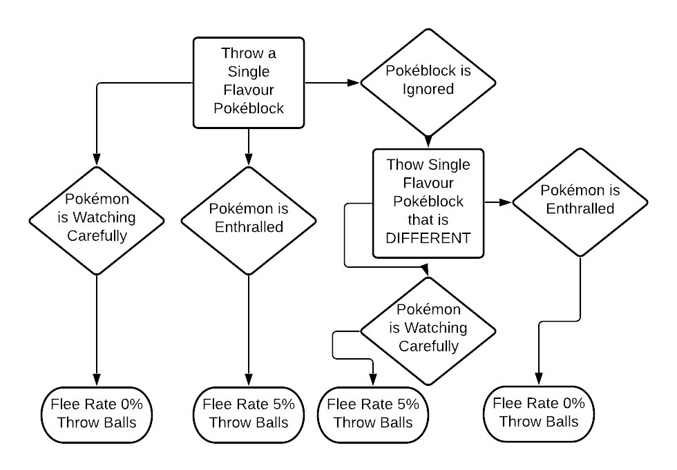Below is the best pattern to use on randomly generated Pokémon in the Hoenn Safari Zone. Different Species of Pokémon do best with different patterns. Refer to the charts below to determine which pattern works best for the Pokémon you are attempting to catch.

**Optimal Pattern:** *throwing a second Pokéblock sometimes*  
On the first turn our goal is to throw a neural Pokéblock. This will bring the Flee Rate down to exactly 0. For the best chance to do this we want to throw a Pokéblock with a single flavour.

If your first Pokéblock **makes the wild Pokémon curious:** the flee rate is now 0%. Throw balls.

If your first Pokéblock is **ignored:** Throw a second Pokéblock of a different flavor than the first. If the second Pokéblock enthralls the wild Pokémon the flee rate is now 0%. If the second Pokéblock does not enthrall the wild Pokémon, the flee rate is now 5%. In either case: throw balls.

If your first Pokéblock **enthralls the Pokémon:** the flee rate is now 5% per turn. Throw balls.

Footnotes on Pokéblocks (TBD)

Synchronize in the Emerald Safari Zone  
There is one further way to increase the odds of throwing a neutral Pokéblock in the Hoenn Safari Zone. Starting in Pokémon Emerald, the ability Synchronize got an overworld effect. When a Pokémon with this ability leads the party, it has a 50% chance to force wild Pokémon to have the same nature as the Synchronizing Pokémon. When encountering Pokémon while there is a Pokéblock in the feeder, the feeder will trigger first. If the 80% chance for the Pokéblock to trigger fails, the Synchronize check will happen. We can combine these powers to leave just a 10% chance for a random nature to trigger. Any nature that is neutral to the Pokéblock you are planning to throw on the first turn will work.

When we combine Synchronize with one of the optimal complex Pokéblocks we can achieve an insane chance to throw a neutral Pokéblock on the first turn.

Odds of Neutral Thrown Pokéblock  
= (80% Feeder Trigger x 99.999% Chance for Neutral Nature)  
+ (10% Synchronize Trigger)  
+ (10% Random Nature x 17/25 chance for random Neutral)  
**= 96.8% Chance for Neutral First Throw**  
1.6% Chance to Throw a Liked Pokéblock  
1.6% Chance to Throw a Disliked Pokéblock

Of course, Synchronize can also be used without the Pokéblock feeder as well. Synchronize on its own can bring any wild Safari encounter to an 84% chance to throw a neutral Pokéblock on the first throw. This could be especially useful for Shuckle since resetting Pokéblock feeders would be brutal.

Shuckle in the Emerald Safari Zone  
As a brief aside, Shuckle is likely one of the rarest Pokémon in the Hoenn Safari Zone. If we were being pedantic, the 5% Level 20 Shuckle is likely the rarest. It has a base 20% encounter rate per Rock Smash, cannot be Illuminated or Area Trapped for, but is affected by the White Flute. However, resetting the rocks requires a map transition – which resets the flute; so you have to use it before each set of Rock Smashes. It is also important to not smash from a bike since the bike has an 0.8x encounter rate modifier.

Calculating Success Rates

[Code for these outputs can be found here](https://github.com/ProfessorRex/HoennSafariZone)

Below are the odds for catching each available species of Pokémon in any condition. Compare success rates to determine whether throwing a Pokéblock will be worth it or not.

Synchronizer’s Nature is assumed to be Neutral to thrown Pokéblock.  
Success rates assume that optimal patterns are followed as outlined on Page 7.  
“Complex Block” Success Rates assume the Rank 1 Complex Block as defined at the bottom of Page 5 is in the Pokéblock feeder.

**DODRIO, PINSIR, AIPOM, WOBBUFFET, HERACROSS, STANTLER, & MILTANK**

Base catch rate: 45

Base catch factor: 3

Modified catch rate: 38

Odds of capture per ball: 8.09%

Odds of fleeing per turn: 15.01%

Odds of capture with **balls only**: **36.94%**

Odds of capture with **random nature**: **69.80%**

Odds of capture with **Synchronizer: 74.01%**

Odds of capture with *spicy* table: 74.24%

Odds of capture with *sour* table: 75.22%

Odds of capture with *sweet* table: 75.35%

Odds of capture with *dry* table: 75.51%

Odds of capture with ***bitter* table**: **75.87%**

Odds of capture with **Complex Block: 76.54%**

Odds of capture with **Complex Block & Synchronize: 77.39%**

**SEAKING, GIRAFARIG, & GLIGAR**

Base catch rate: 60

Base catch factor: 4

Modified catch rate: 51

Odds of capture per ball: 10.66%

Odds of fleeing per turn: 15.01%

Odds of capture with **balls only: 44.27%**

Odds of capture with **random nature**: **74.2%**

Odds of capture with **Synchronizer: 78.14%**

Odds of capture with *spicy* table: 78.14%

Odds of capture with *sour* table: 79.13%

Odds of capture with *sweet* table: 79.26%

Odds of capture with *dry* table: 79.42%

Odds of capture with ***bitter* table**: **79.79%**

Odds of capture with **Complex Block: 80.52%**

Odds of capture with **Complex Block & Synchronize: 81.32%**

**GOLDUCK, XATU, & OCTILLERY**

Base catch rate: 75

Base catch factor: 5

Modified catch rate: 63

Odds of capture per ball: 12.33%

Odds of fleeing per turn: 15.01%

Odds of capture with **balls only: 48.36%**

Odds of capture with **random nature**: **75.86%**

Odds of capture with **Synchronizer: 79.60%**

Odds of capture with *spicy* table: 79.45%

Odds of capture with *sour* table: 80.44%

Odds of capture with *sweet* table: 80.58%

Odds of capture with *dry* table: 80.73%

Odds of capture with ***bitter* table:** **81.10%**

Odds of capture with **Complex Block: 81.85%**

Odds of capture with **Complex Block & Synchronize: 82.61%**

**QUAGSIRE**

Base catch rate: 90

Base catch factor: 7

Modified catch rate: 89

Odds of capture per ball: 19.75%

Odds of fleeing per turn: 15.01%

Odds of capture with **balls only: 62.11%**

Odds of capture with **random nature**: **79.10%**

Odds of capture with **Synchronizer: 81.98%**

Odds of capture with *spicy* table: 81.34%

Odds of capture with *sour* table: 82.28%

Odds of capture with *sweet* table: 82.41%

Odds of capture with *dry* table: 82.56%

Odds of capture with ***bitter* table**: **82.91%**

Odds of capture with **Complex Block: 83.72%**

Odds of capture with **Complex Block & Synchronize: 84.31%**

**GLOOM, RHYHORN, TEDDIURSA, HOUNDOUR, & PHANPY**

Base catch rate: 120

Base catch factor: 9

Modified catch rate: 114

Odds of capture per ball: 23.42%

Odds of fleeing per turn: 15.01%

Odds of capture with **balls only: 67.07%**

Odds of capture with **random nature**: **79.81%**

Odds of capture with Synchronizer: 82.37%

Odds of capture with *spicy* table: 81.57%

Odds of capture with *sour* table: 82.49%

Odds of capture with *sweet* table: 82.62%

Odds of capture with *dry* table: 82.76%

Odds of capture with ***bitter* table**: **83.10%**

Odds of capture with **Complex Block: 83.92%**

Odds of capture with **Complex Block & Synchronize: 84.45%**

**PIKACHU, PYSDUCK, DODUO, NATU, MARILL, PINECO, SNUBBULL, SHUCKLE, & REMORAID**

Base catch rate: 190

Base catch factor: 14

Modified catch rate: 178

Odds of capture per ball: 40.96%

Odds of fleeing per turn: 15.01%

Odds of capture with **balls only: 82.21%**

Odds of capture with random nature: 81.46%

Odds of capture with **Synchronizer: 83.22%**

Odds of capture with *spicy* table: 81.99%

Odds of capture with *sour* table: 82.86%

Odds of capture with *sweet* table: 82.98%

Odds of capture with *dry* table: 83.12%

Odds of capture with ***bitter* table**: **83.44%**

Odds of capture with **Complex Block: 84.28%**

Odds of capture with **Complex Block & Synchronize: 84.65%**

**ODDISH, GEODUDE, GOLDEEN, MAGIKARP, HOOTHOOT, LEDYBA, SPINARAK, & WOOPER**

Base catch rate: 255

Base catch factor: 20

Modified catch rate: 255

Odds of capture per ball: 50.28%

Odds of fleeing per turn: 15.01%

Odds of capture with **balls only: 87.07%**

Odds of capture with random nature: 81.89%

Odds of capture with Synchronizer: 83.44%

Odds of capture with *spicy* table: 82.08%

Odds of capture with *sour* table: 82.94%

Odds of capture with *sweet* table: 83.05%

Odds of capture with *dry* table: 83.19%

Odds of capture with *bitter* table: 83.50%

Odds of capture with Complex Block: 84.37%

Odds of capture with Complex Block & Synchronize: 84.69%

**MAREEP & SUNKERN**

Base catch rate: 235

Base catch factor: 18

Modified catch rate: 229

Odds of capture per ball: 50.28%

Odds of fleeing per turn: 15.01%

Odds of capture with **balls only: 87.07%**

Odds of capture with random nature: 81.89%

Odds of capture with Synchronizer: 83.44%

Odds of capture with *spicy* table: 82.08%

Odds of capture with *sour* table: 82.94%

Odds of capture with *sweet* table: 83.05%

Odds of capture with *dry* table: 83.19%

Odds of capture with *bitter* table: 83.50%

Odds of capture with Complex Block: 84.37%

Odds of capture with Complex Block & Synchronize: 84.69%

Questions can be directed to me on any of the following media platforms:

Discord: [The Rex Men](https://discord.gg/Pkt8T7d) Twitch: [BrofessorsLab](https://www.twitch.tv/brofessorslab) Reddit: [MineOSaurus_Rex](https://www.reddit.com/user/MineOSaurus_Rex/)

Instagram: [rex_phd](https://www.instagram.com/rex_phd/) Youtube: [Professor Rex](https://www.youtube.com/channel/UCqsQ925jAVYz-asz--B5Nfw)

Email: [the.professor.rex@gmail.com](mailto:the.professor.rex@gmail.com)